## **DBMS Notes**

* **Types of Databases**
  + Hierarchical
  + Relational
  + Network
  + NoSQL
* Requirements of a database:
  + Integrity
  + Availability
  + Security
  + Independent of Application
  + Concurrent
* Problems faced with file based systems
  + Dependency of program on structure of data
  + Complex process to retrieve data
  + Loss of data on concurrent access
  + Inability to give access based on record (Security)
  + Data Redundancy
* In a Database table
  + ROW → Tuple / Records
  + COLUMN → Attributes / Fields
* **Cardinality** is the number of rows in the database table
* **Degree of Relation** is the number of Columns
* **Domain** is set of allowable values for 1 / more Columns
* Null represents a value of an attribute that is currently unavailable
* **Primary Key** :( It is a candidate key ) Set of unique values in a row based on which a table can be identified
* **Foreign Key** : The common column between two tables in a database
* **Candidate Key** : Set of Possible Primary keys ( columns that can become a primary key )
* **Cardinality of Relationship**:
  + One-one : relationship between one instance in one table and another instance in another table.
  + One to many: relationship between one instance in one table and more than one instance in another table.
  + Many to Many: relationship between more than one instance in one table and more than one instance in another table.

**CROW Foot Notation**

* + 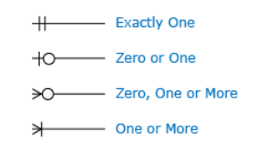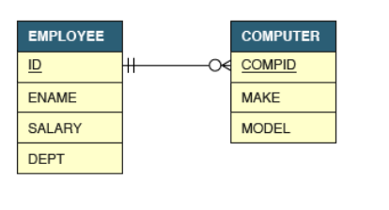
* **Types of Commands**

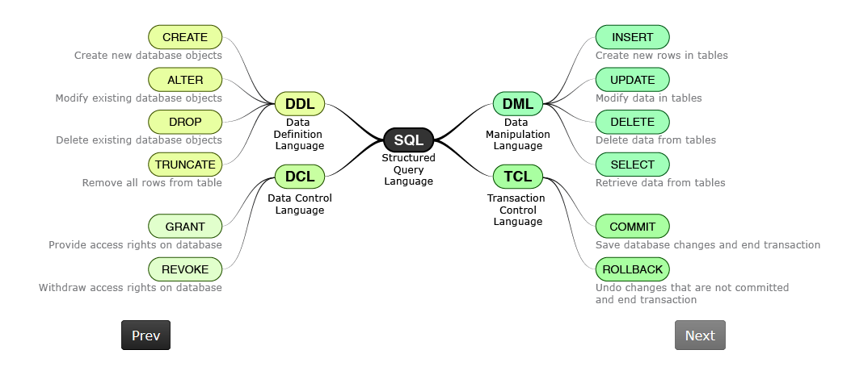

**DataBase Operators:**

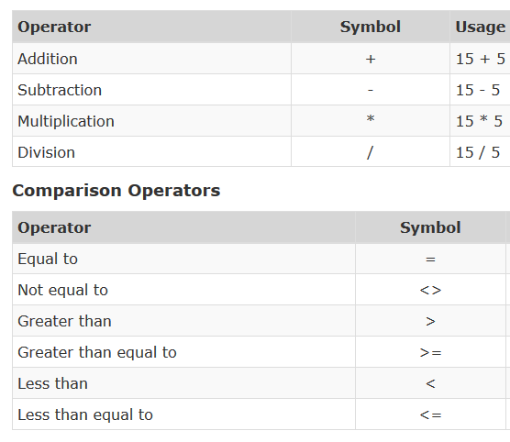

**Creating & Dropping tables in SQL:**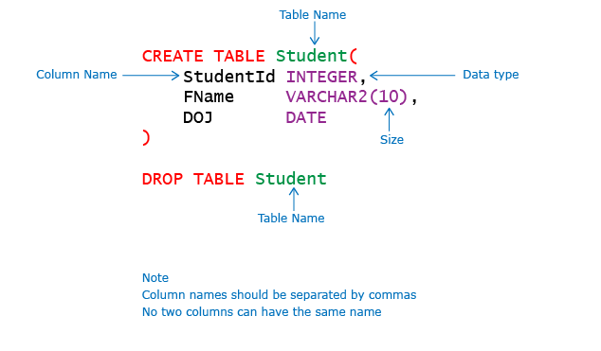

**Alter Table in SQL:**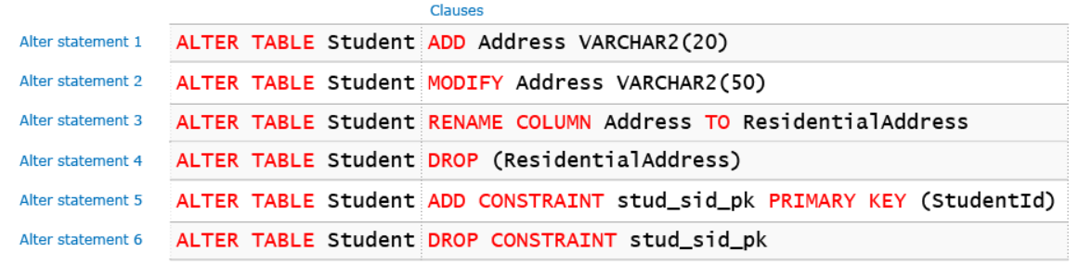

**Insert Table Syntax SQL:**

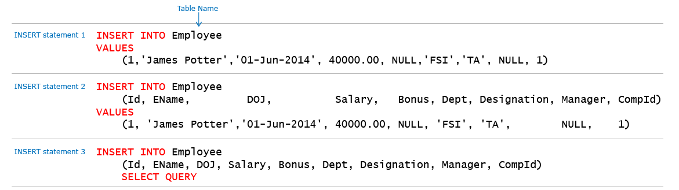

**Date should be in order YYYY-MM-DD**

**Selecting columns from a table:**

**Eg:**

Select * from table_name

Select Id EName, Salary FROM Employee ( OR )

Select Id as EName, Salary as SalaryMonthly from Employee

* **Removing / Displaying Columns Without Duplicates:**

**Eg:** SELECT DISTINCT Dept FROM Employee

* **Updating a Database**

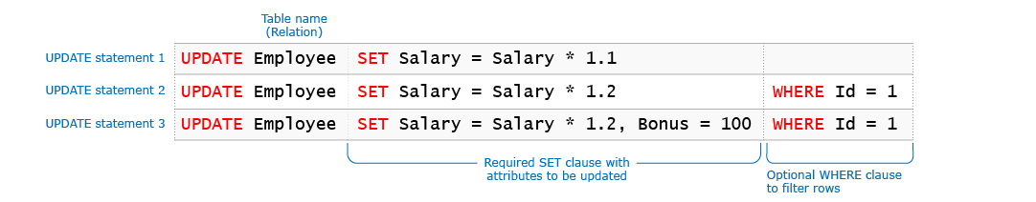

Always use a comma ( , ) when using multiple updates with a table

* **Deleting from a Database**

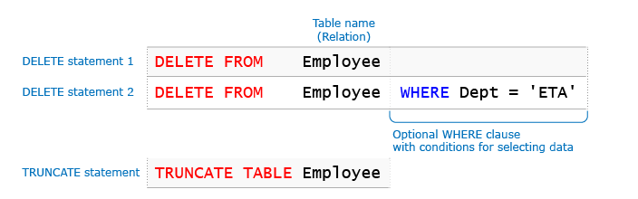

**Truncate** is used to delete all the rows from the database ( without accepting any condition ). Hence it is faster.

Always use “**IS**” and not “**=**” when using it with **Delete** and **NULL**

**LEARN WILDCARDS:**

**https://www.w3schools.com/sql/sql_wildcards.asp**

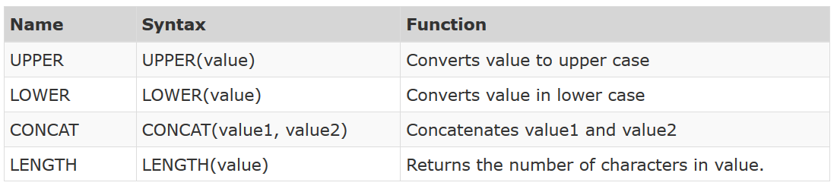

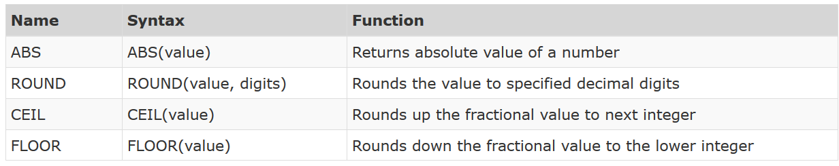

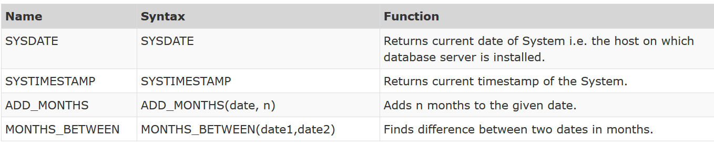

* **Ordering the table based on ascending/ descending order:**

When there are 2 columns, the table is first sorted based on the first column and when there are conflicting columns then it follows the second column.

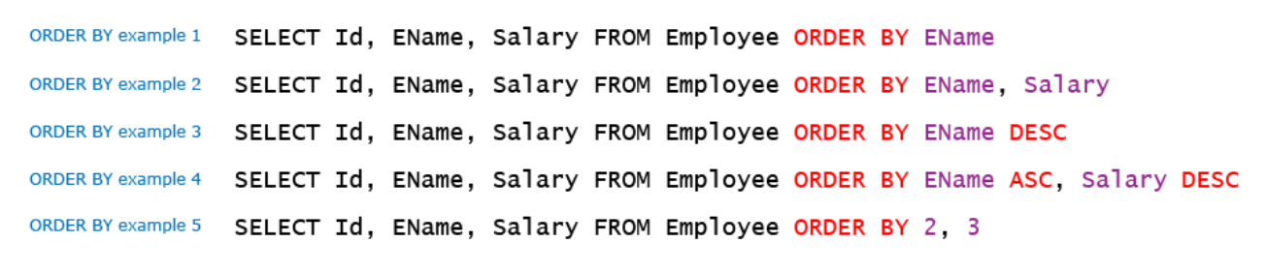

**GROUP BY:**

This command can be used to get a summarised version of the existing table

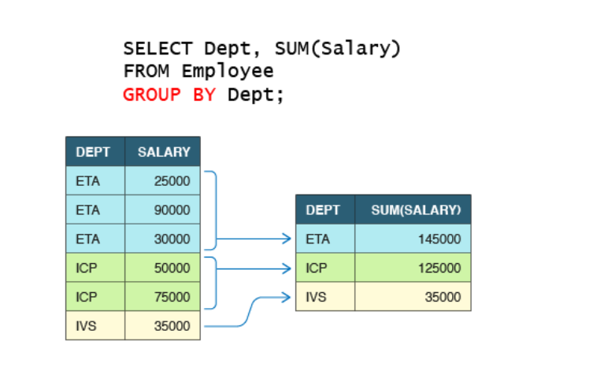



**DIFFERENCE Btw Union and Union ALL**

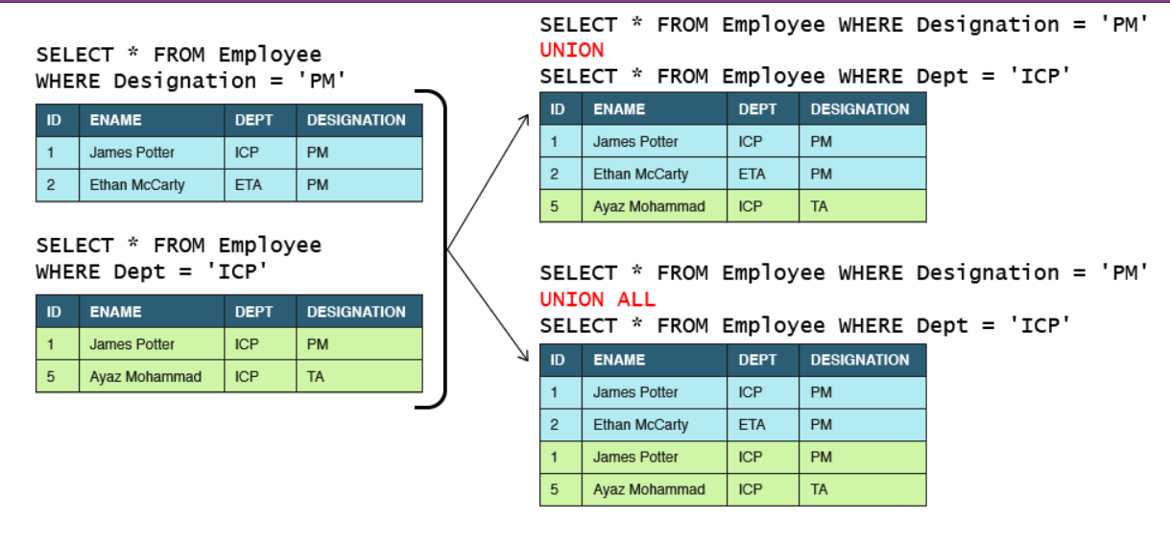

**JOINS**

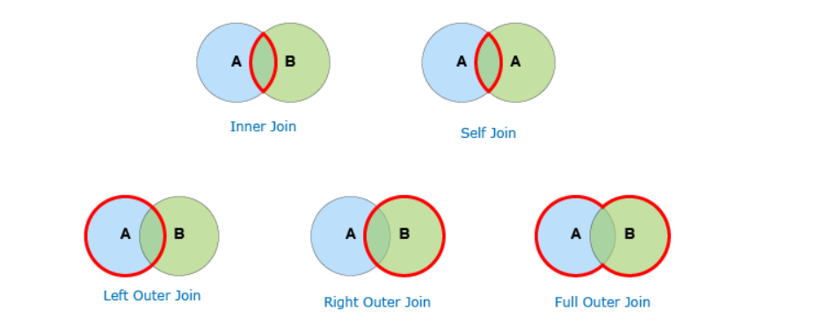

**Normalizations:**

Refer the below link for normalization explaination

**https://www.geeksforgeeks.org/database-normalization-normal-forms/**